**Helm** is a package manager for **Kubernetes** ,that allows operators to more easily package, and deploy applications and services onto Kubernetes clusters

*To deploy an application to kubernetes could be a complex task and setting up a single application can involve writing interdependent kubernetes resources such as Deployments,services,secrets,ConfigMaps etc

**Why we need Helm charts:**

* Makes application deployment easy
* Standardize and reusable(rather than hardcoding)
* Reduces deployment complexity

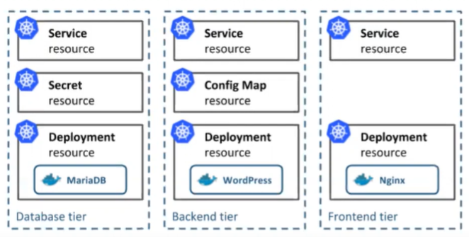

**Architecture (V2 & V3) --Differences**

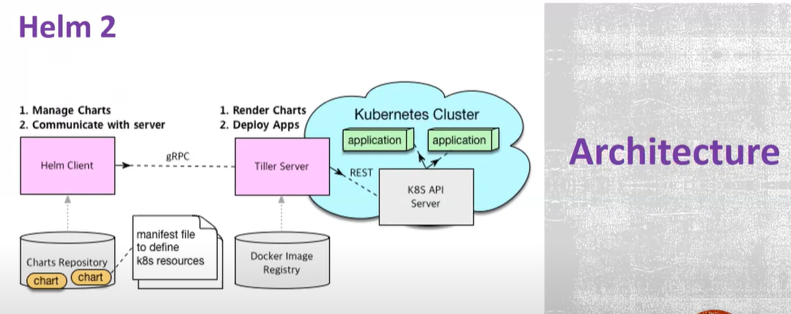

* **Helm client:** It interacts with Tiller server and it also manages the charts
* **Tiller:**It interacts with K8s API server and deploys objects onto the cluster
* It uses two way strategic merge patch(**proposed chart,previous chart manifest**) if there is any change it is going to apply on K8s cluster,,if the changes are applied through ADHOC commands then those changes are not considered.

Example 1:

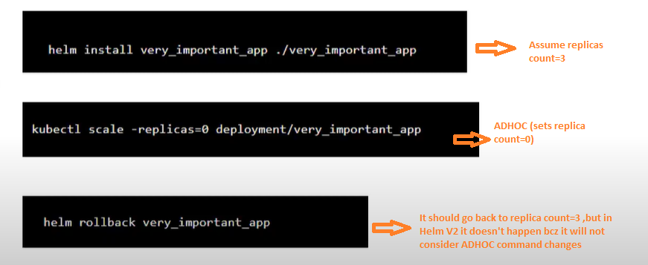

Example 2:

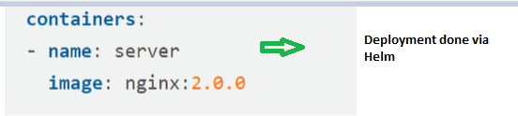

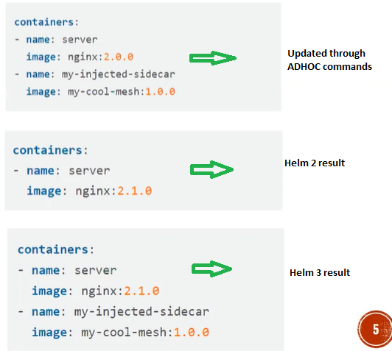

**\*Validating chart values with JSONschema**(Helm3 ,,if we give name,protocol,port type wrongly Helm3 compares this values with JSONSchema.

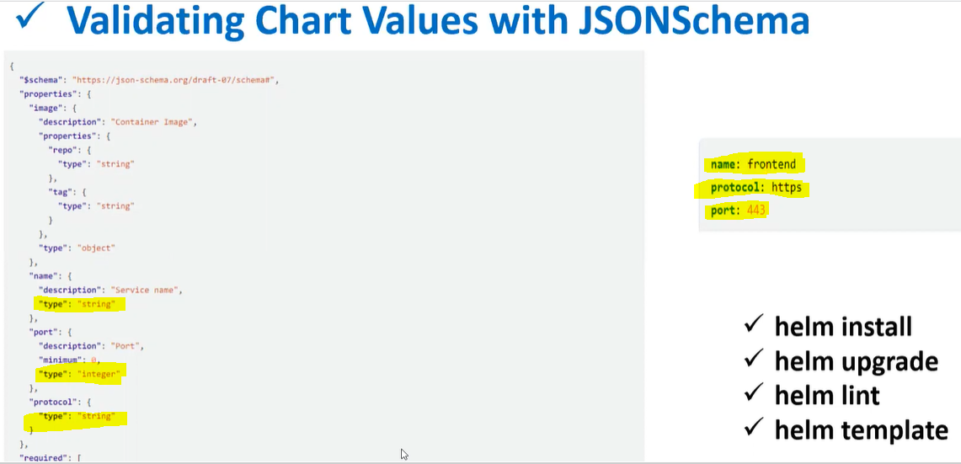

**\*\*** Consolidation of requirements.yml to Chart.yml (requirement.yml will be deprecated in future)

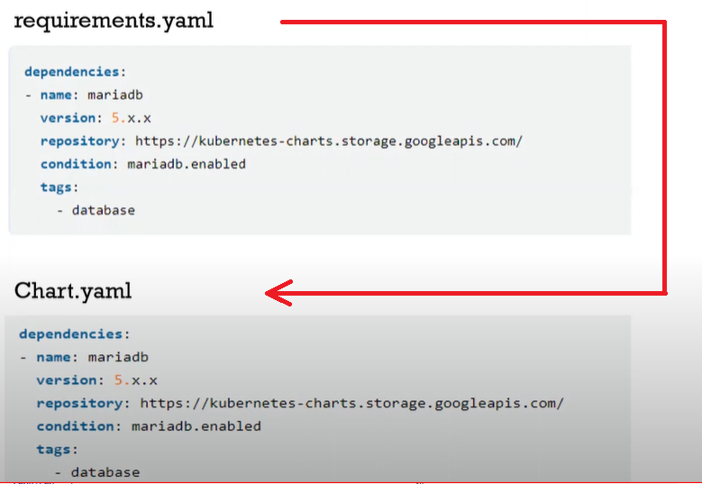

**\*\***Name field is required in Helm3 for install ,,where as in Helm2 it was not mandatory

**command changes

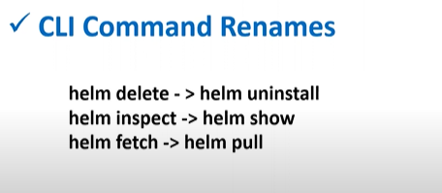

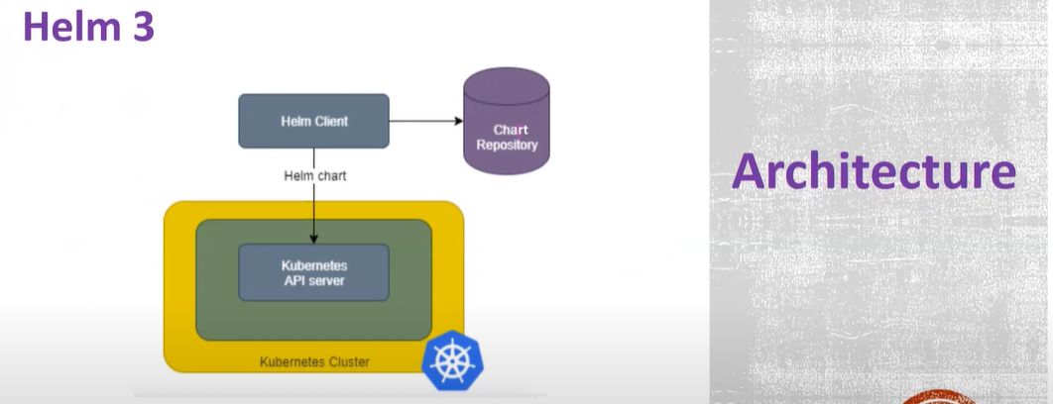

* It is client only architecture
* Helm client directly interacts with API server
* Supports RBAC
* Uses 3 way strategic merge patch(Old,live state and new manifest) it considers these three while generating new patch.

**Charts** : The format ,which Helm uses to package the application is called Charts

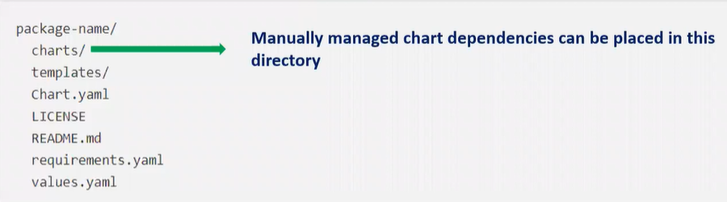

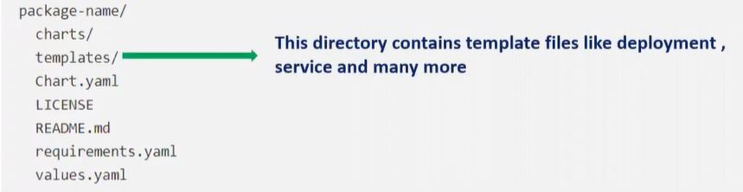

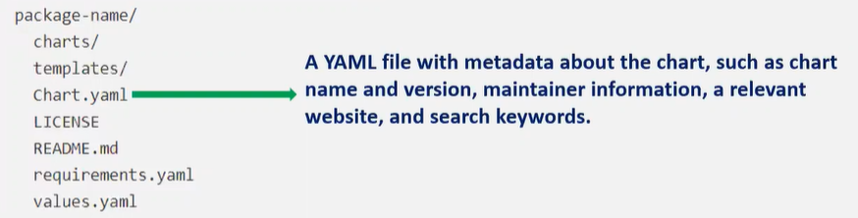

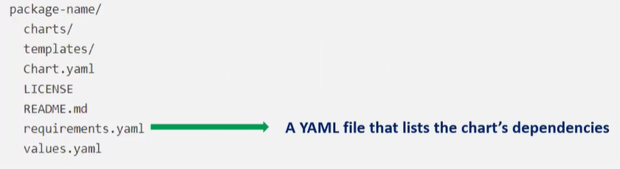

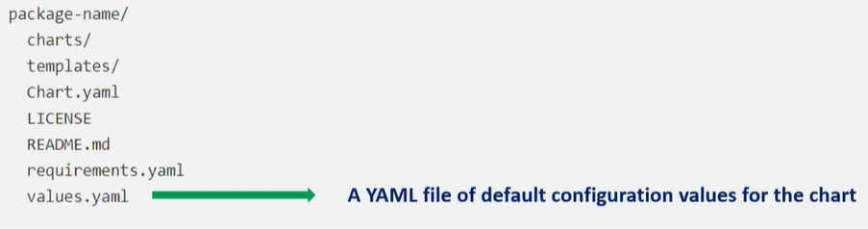

**WORKFLOW:**

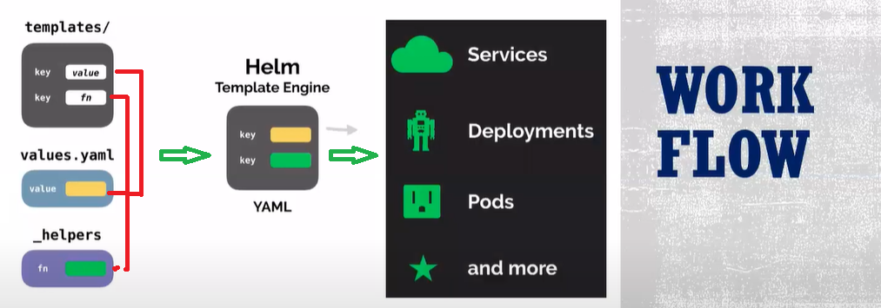

**Helm Installation in ubuntu 16.04**

* curl -fsSL -o get_helm.sh <https://raw.githubusercontent.com/helm/helm/master/scripts/get-helm-3>
* chmod 700 get_helm.sh
* ./get_helm.sh

**helm uninstallation**

* + which helm ( to see which folder its installed )
  + rm -rf /usr/local/bin/helm

**Helm3 Commands:**

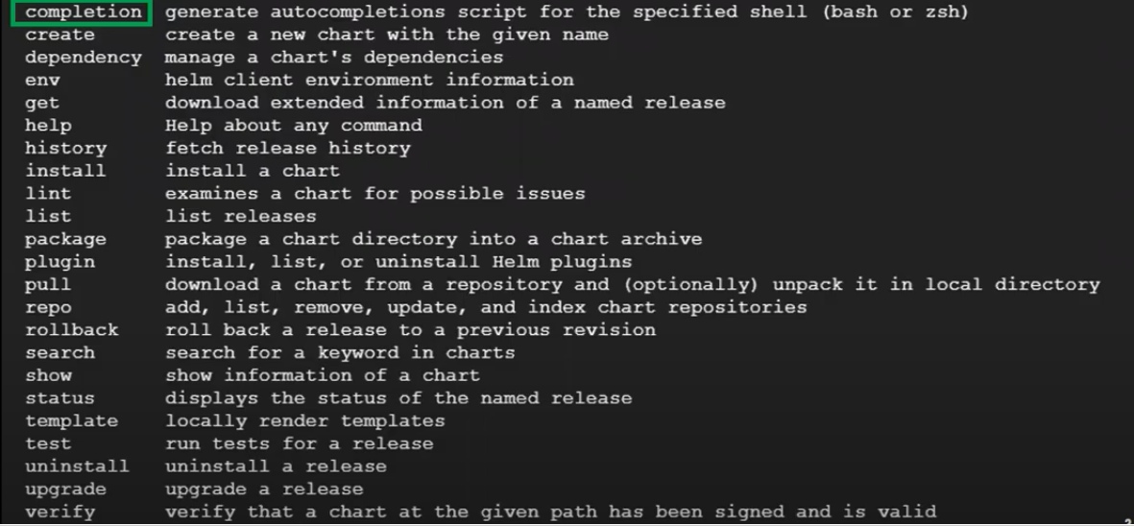

**Create:**

